|  |  |
| --- | --- |
|  |  |
| Supply Chain Management |  |
|  |  |
|  | 10th April, 2024RCDS Tableau |
|  | Anshika Sharma- A061 Ashwini Shetty- A063 |

|  |  |  |  |
| --- | --- | --- | --- |
|  |  |  |  |
|  | Overview of SCM :-Supply chain management (SCM) orchestrates the seamless flow of goods and services, from their inception to reaching the end consumer, integrating processes and information along the way. Central to SCM is the optimization of every step, ensuring efficiency, effective ness, and customer satisfaction. By meticulously planning, organizations forecast demand, fine-tune production schedules, and maintain optimal inventory levels to meet customer needs while minimizing costs. Sourcing involves identifying reliable suppliers, negotiating contracts, and nurturing relationships to secure a steady supply of materials or services. This holistic approach ensures that products are delivered precisely where and when they are needed, fulfilling customer expectations for quality, timeliness, and service. | |  |
|  | Key components of supply chain management include:   * Planning: This involves forecasting demand, developing production plans, and determining inventory levels to meet customer demand while minimizing costs. * Sourcing: Identifying and selecting suppliers, negotiating contracts, and managing relationships with suppliers to ensure a reliable supply of materials or services. * Manufacturing/Production: Transforming raw materials into finished products through efficient production processes. | * Logistics: Managing the movement and storage of goods, including transportation, warehousing, and distribution. * Inventory Management: Ensuring that the right amount of inventory is available at the right time to meet customer demand while minimizing holding costs and stockouts. * Information Systems: Utilizing technology and information systems to track inventory, monitor supplier performance, and coordinate activities across the supply chain. |  |

## OBJECTIVES

* Efficiency: Ensuring that goods and services are produced and delivered in the most cost-effective manner possible.
* Effectiveness: Ensuring that the right products are delivered to the right place, at the right time, and in the right quantity to meet customer demand.
* Customer satisfaction: Meeting or exceeding customer expectations in terms of product quality, delivery times, and service levels.

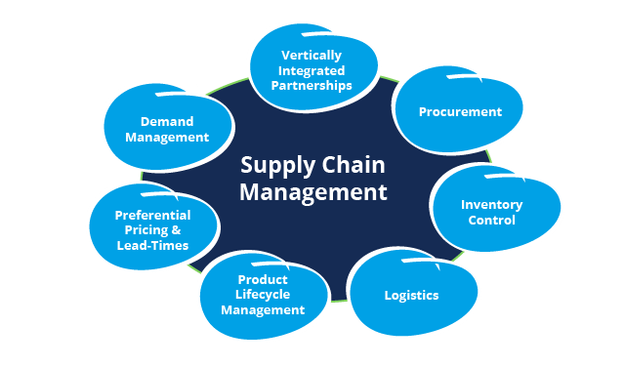

## Introduction to Dataset: -

The dataset comprises detailed information about customer orders, products, and shipping logistics, offering insights into sales, delivery status, and customer profiles for analysis and optimization in supply chain management or retail operations.

Dataset consists of columns named: -

**Category Id:** This column may contain numerical identifiers for different product categories.

**Category Name:** This column likely contains the names or descriptions of the product categories corresponding to the Category Id.

**Customer details:** These columns likely contain information about the customers, including their names, addresses, segment (e.g., retail, wholesale), and location details.

**Delivery Status, Late delivery risk, Days for shipment (scheduled), Days for shipping (real), Shipping Mode, shipping date (date-orders):** These columns likely pertain to shipping and delivery details, including delivery status, shipping dates, shipping modes, and any delays or risks associated with late deliveries.

**Department Id, Department Name, Market:** These columns may relate to the departments or categories within the organization, as well as the market or region where orders were placed.

**Order City, Order Country, order date, Order Region-State, Order Status, Order Zip-code:** These columns likely contain information about the orders, including order ids, dates, statuses, and the locations (city, country, region, state, and zip-code) associated with the orders.

**Product Details, Product Price, Sales:** These columns likely contain details about the products, including their names, identifiers, categories, prices, and sales figures.

**Type, Benefit per order, Order details:** These columns may relate to various aspects of the orders and order items, including discounts, prices, quantities, and profits.

**Latitude, Longitude:** These columns likely contain geographical coordinates associated with customer locations or order delivery destinations.

**No. of Records:** This column may indicate the number of records or entries in the dataset.

**Sales per customer:** This column may represent the total sales attributed to each individual customer.

1.The bar chart titled “Department by Late Delivery” that shows the number of late deliveries per department.

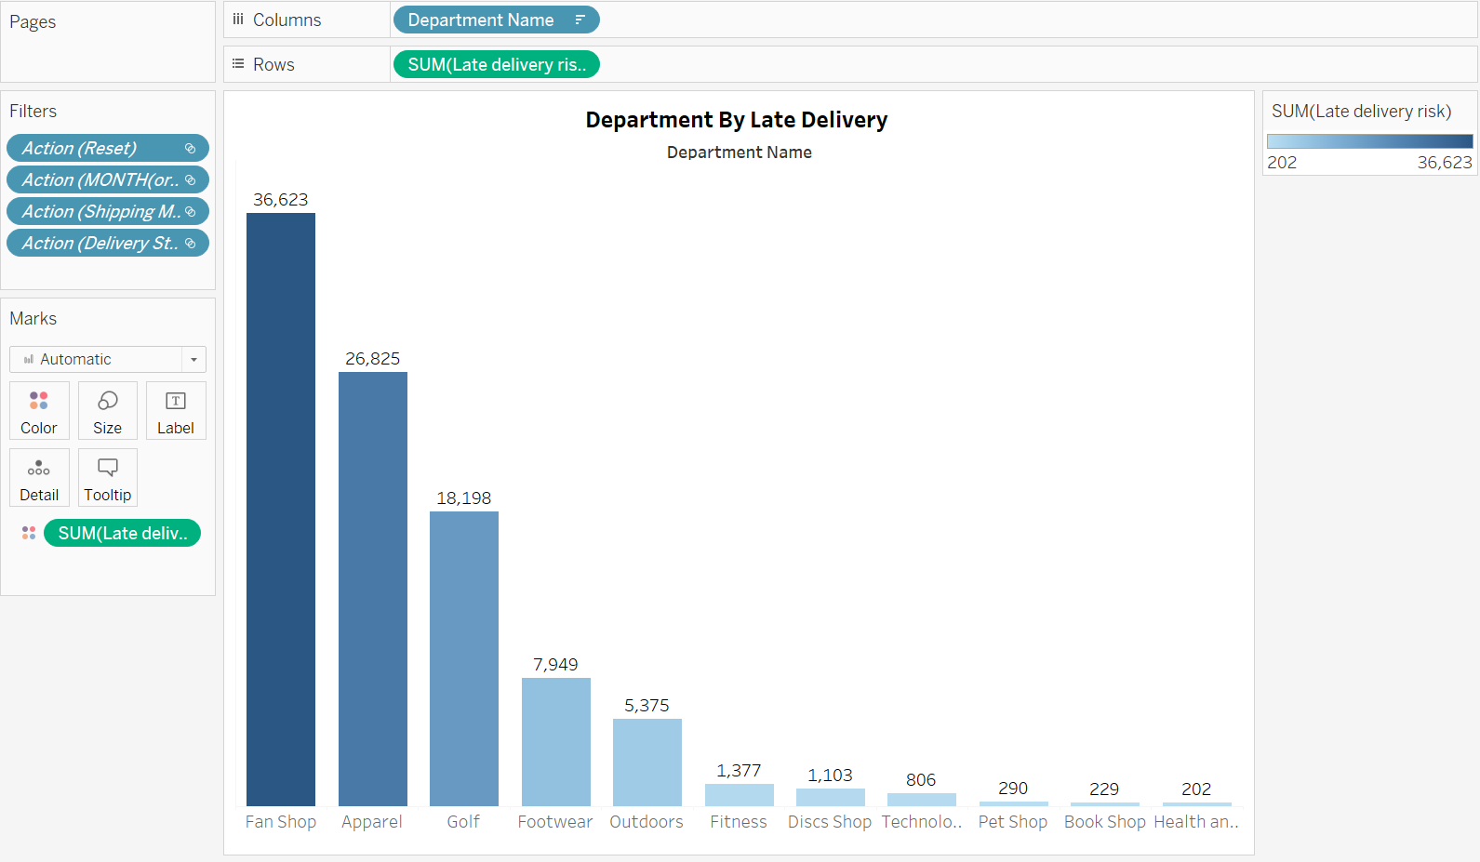

This is a typical issue in supply chain management, as late deliveries can disrupt production schedules, lead to stockouts, and cause customer dis-satisfaction.

* Departments: The x-axis shows the departments, which include Fan Shop, Apparel, Footwear, Outdoors, Fitness, Discs Shop, Technology, Pet Shop, Book Shop, and Health and Beauty.
* Number of Late Deliveries: The y-axis shows the number of late deliveries. The department with the most lately deliveries is Fan Shop (36,623), followed by Apparel (26,825) and Footwear (18,198).

2.The graph shows ship models by delivery status.

The data shows the number of shipments for each of the following categories:

* Standard Class
* Second Class
* First Class
* Same Day.

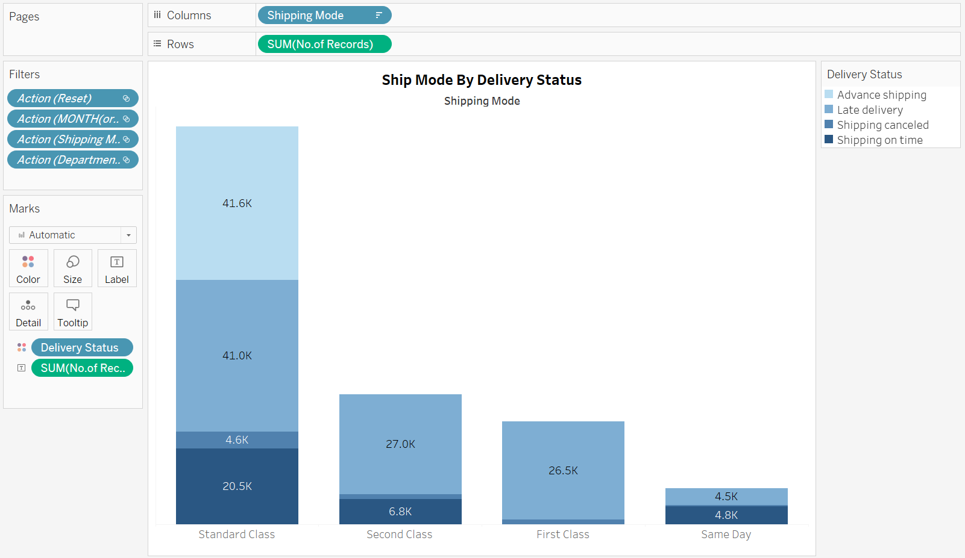

* Shipping Mode: The x-axis shows the different shipping modes offered, which are Standard Class, Second Class, and First-Class Same Day.
* Number of Shipments: The y-axis shows the total number of shipments for each shipping mode. There are 41,600 total shipments. Standard Class is the most common shipping mode, with 41,000 shipments. Second Class is next with 4,600 shipments, and First-Class Same Day is the least common with 200 shipments

3. The image shows a line graph with two lines representing “Year by Sales” and “Profit” over a period from December 2014 to December 2017.

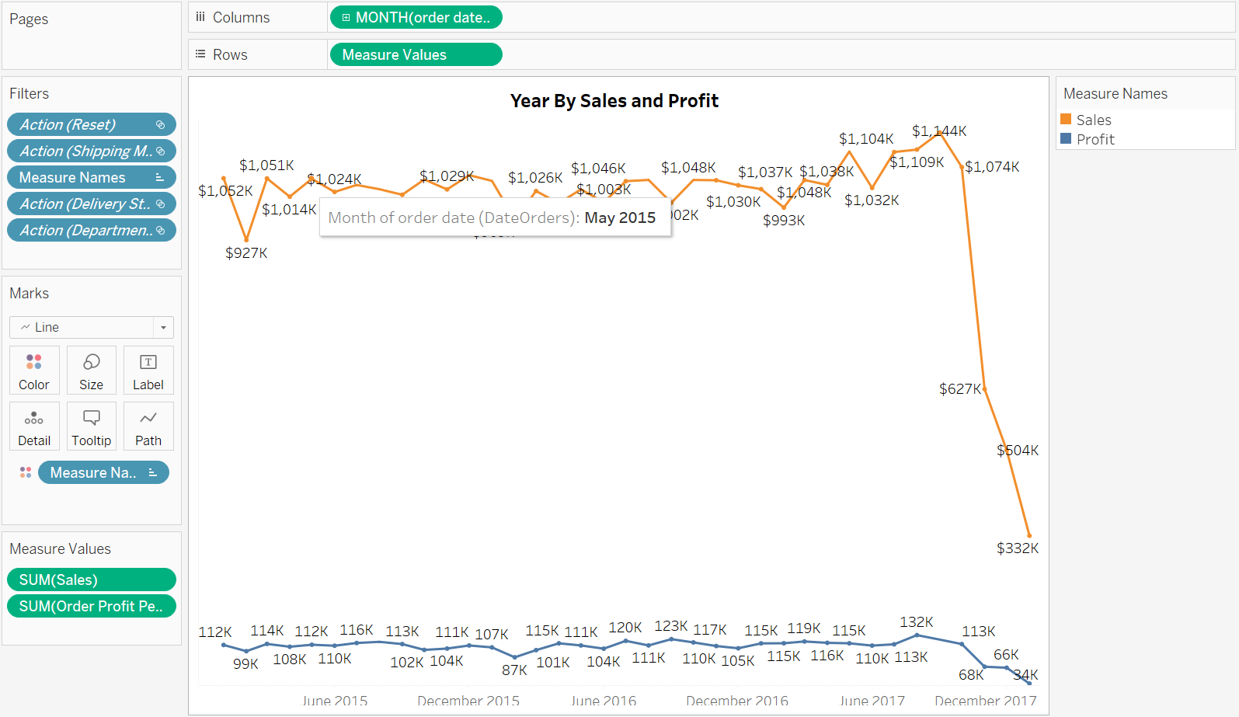

* The X-axis indicates time, with labels December and June of each year, while the Y-axis seems to indicate monetary values, though the units are not expressly stated.
* The Sales line appears to start at approximately 927K in December 2014 and ends near 832K in December 2017. The Profit line begins around 114K in December2014, generally fluctuating but trending downwards, and ends significantly lower near 63K in December 2017.

4. This is a donut chart which represents “Total Orders” which is given as 180.5K (likely meaning180,500 orders).

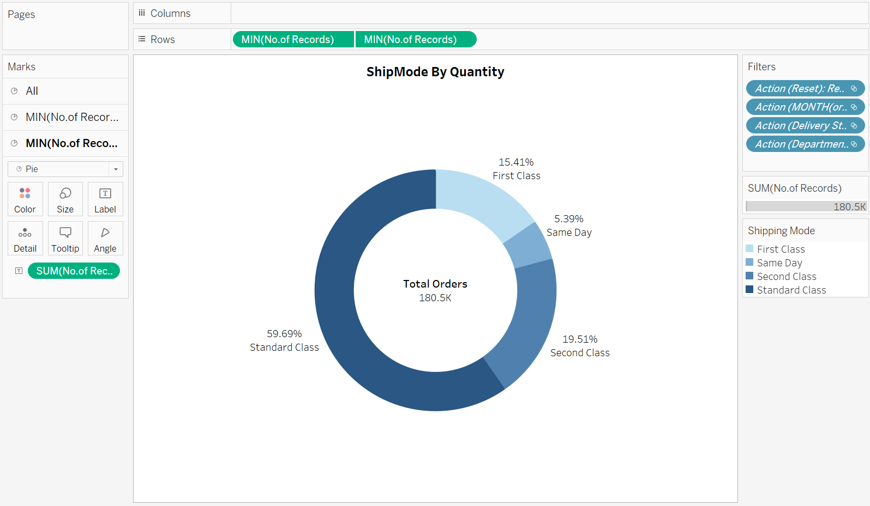

The chart depicts the distribution of orders across three shipping categories:

* Standard Class (59.69%)
* Second Class (19.51%)
* First Class (15.41%)

In supply chain management, these Categories likely represent varying levels of shipping speed and cost, with Standard being the norm, Second Class offering faster delivery at a moderate cost, and First Class providing the fastest, premium service at a higher expense.

5.The graph is “Order Status by Order”.

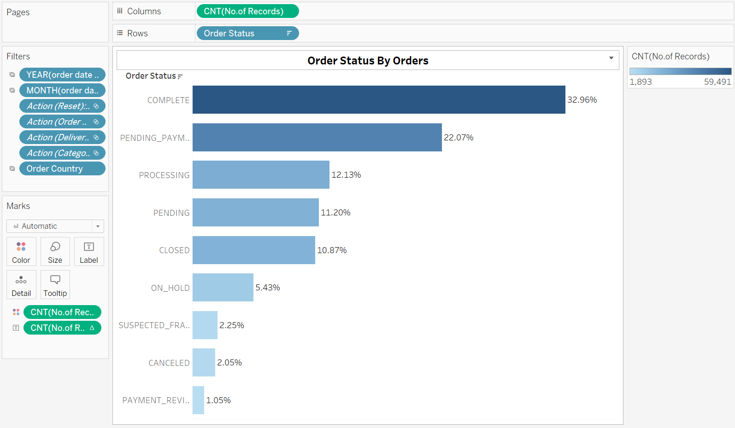

There are eight different categories of order statuses, each with a corresponding bar and percentage.

The bars represent the proportion of orders in each status, and the lengths of the bars are proportional to the percentage values listed next to them.

The rows representing different order statuses and columns indicating the count of records for each status.6. The pie chart titled “Delivery Status by Orders”.

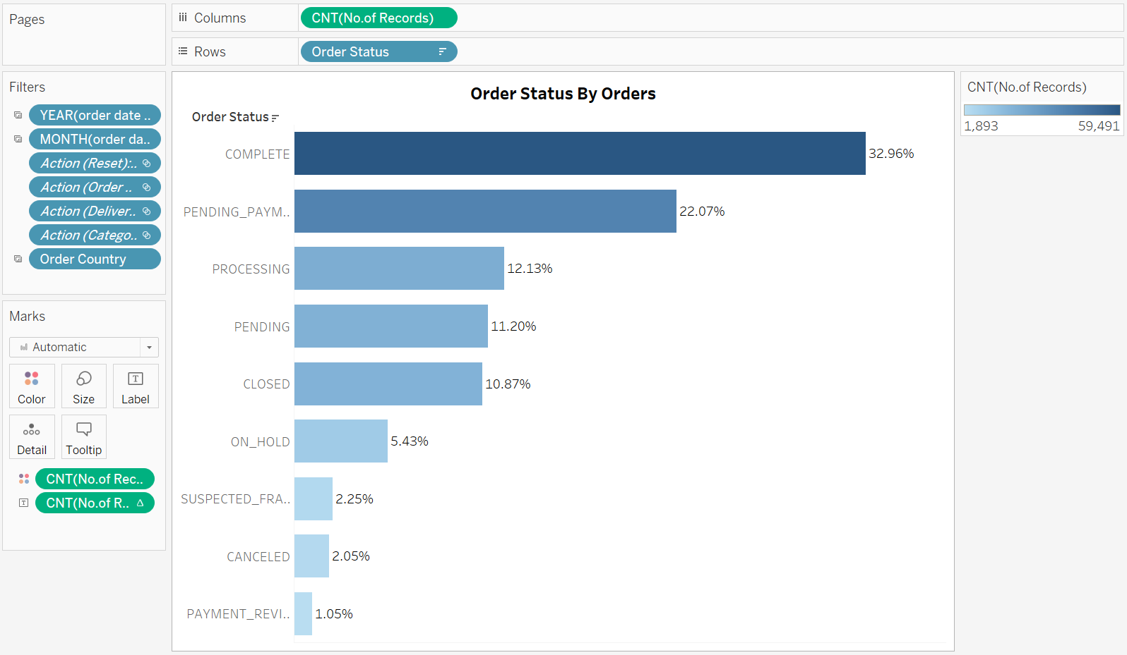

The chart is divided into three segments, each representing a different category of delivery status.

The largest segment represents late deliveries, which makes up over half of the chart.

The next largest is advance shipping, followed by on-time shipping, and the smallest segment is for canceled shipments.

7. The **tree map chart** that is used to represent categorical data through rectangles whose sizes are proportional to the sales and profits of different categories.

The chart appears to be segmented primarily by sales and profit categories. The larger a rectangle, the higher the value it represents.

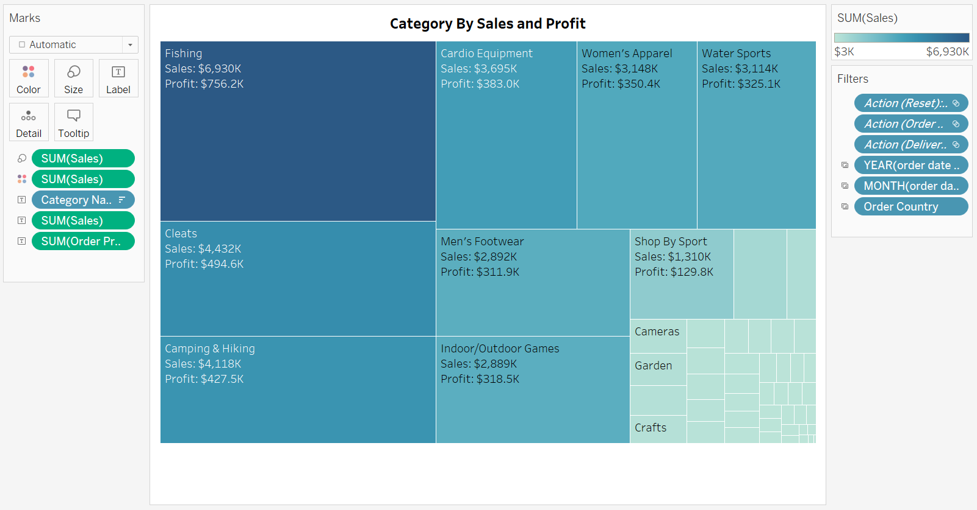

The tree map chart displays the following categories of outdoor products along with their

corresponding sales and profit figures:

1. Fishing

* Sales: $500,000
* Profit: $80,000

2. Water Sports

* Sales: $400,000
* Profit: $70,000

3. Men’s Footwear

* Sales: $300,000
* Profit: $50,000

The rectangles are color-coded, where the intensity of the color might represent the profitability ratio.

8. The Chart is titled by “Country by Sales” where there are orange circles of varying sizes overlaid on top of it.

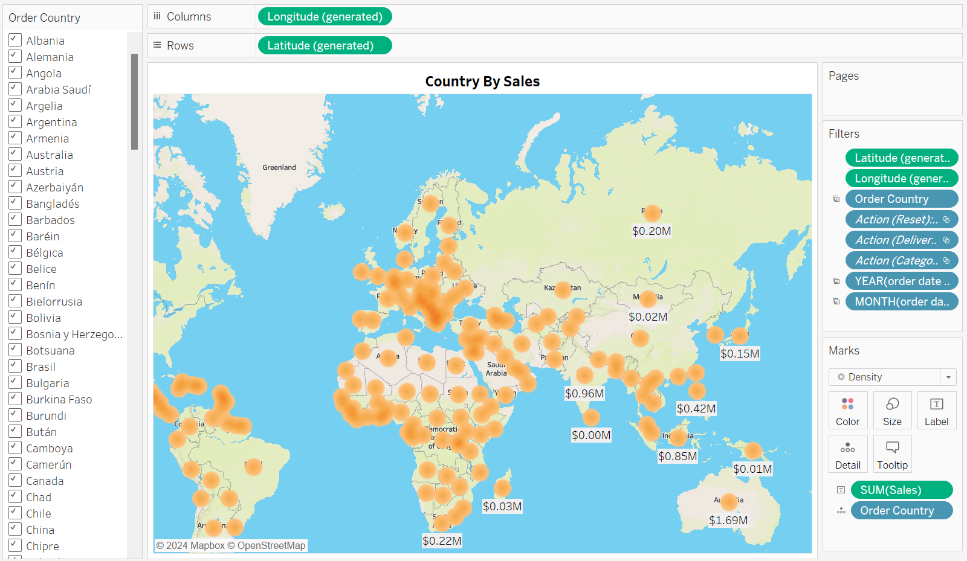

* Each circle’s size corresponds to sales data by country, as indicated at the top of the map.
* The larger the circle, the higher the sales in that country. Numerical sales values are displayed within some of the circles.
* The x-axis represents the longitudinal coordinates (longitude) of the countries, and the y-axis represents the latitudinal coordinates (latitude) of the countries on the world map. These axes help in geospatially locating and plotting the sales data for each country on the map.
* The value of sales for the United States, indicated by the largest orange circle on the map, is $4.88M.

## DASHBOARD